Project: Data Lake

Introduction
A music streaming startup, Sparkify, has grown their user base and song database even more and want to move their data warehouse to a data lake. Their data resides in S3, in a directory of JSON logs on user activity on the app, as well as a directory with JSON metadata on the songs in their app.

As their data engineer, you are tasked with building an ETL pipeline that extracts their data from S3, processes them using Spark, and loads the data back into S3 as a set of dimensional tables. This will allow their analytics team to continue finding insights in what songs their users are listening to.

You'll be able to test your database and ETL pipeline by running queries given to you by the analytics team from Sparkify and compare your results with their expected results.

Project Description
In this project, you'll apply what you've learned on Spark and data lakes to build an ETL pipeline for a data lake hosted on S3. To complete the project, you will need to load data from S3, process the data into analytics tables using Spark, and load them back into S3. You'll deploy this Spark process on a cluster using AWS.

Project Datasets

Project Datasets
You'll be working with two datasets that reside in S3. Here are the S3 links for each:
Song data: s3://udacity-dend/song_data
Log data: s3://udacity-dend/log_data

Song Dataset
The first dataset is a subset of real data from the Million Song Dataset. Each file is in JSON format and contains metadata about a song and the artist of that song. The files are partitioned by the first three letters of each song's track ID. For example, here are filepaths to two files in this dataset.
song_data/A/B/C/TRABCEI128F424C983.json
song_data/A/A/B/TRAABJL12903CDCF1A.json
And below is an example of what a single song file, TRAABJL12903CDCF1A.json, looks like.
{"num_songs": 1, "artist_id": "ARJIE2Y1187B994AB7", "artist_latitude": null, "artist_longitude": null, "artist_location": "", "artist_name": "Line Renaud", "song_id": "SOUPIRU12A6D4FA1E1", "title": "Der Kleine Dompfaff", "duration": 152.92036, "year": 0}

Log Dataset
The second dataset consists of log files in JSON format generated by this event simulator based on the songs in the dataset above. These simulate app activity logs from an imaginary music streaming app based on configuration settings.
The log files in the dataset you'll be working with are partitioned by year and month. For example, here are filepaths to two files in this dataset.
log_data/2018/11/2018-11-12-events.json
log_data/2018/11/2018-11-13-events.json
And below is an example of what the data in a log file, 2018-11-12-events.json, looks like.
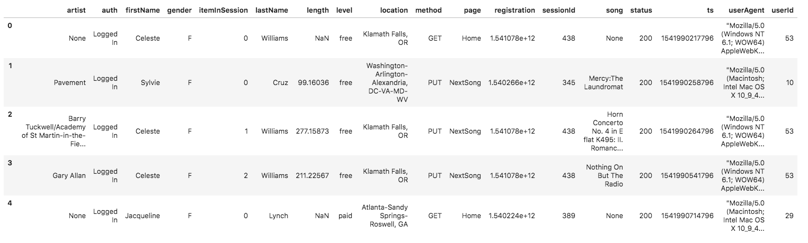

Project Instructions

Schema for Song Play Analysis
Using the song and log datasets, you'll need to create a star schema optimized for queries on song play analysis. This includes the following tables.

Fact Table
- songplays - records in log data associated with song plays i.e. records with page NextSong
songplay_id, start_time, user_id, level, song_id, artist_id, session_id, location, user_agent

Dimension Tables
- users - users in the app
user_id, first_name, last_name, gender, level
- songs - songs in music database
song_id, title, artist_id, year, duration
- artists - artists in music database
artist_id, name, location, lattitude, longitude
- time - timestamps of records in songplays broken down into specific units
start_time, hour, day, week, month, year, weekday

Project Template
To get started with the project, go to the workspace on the next page, where you'll find the project template. You can work on your project with a smaller dataset found in the workspace, and then move on to the bigger dataset on AWS.
Alternatively, you can download the template files in the Resources tab in the classroom and work on this project on your local computer.
The project template includes three files:
etl.py reads data from S3, processes that data using Spark, and writes them back to S3
dl.cfgcontains your AWS credentials
README.md provides discussion on your process and decisions

Document Process
Do the following steps in your README.md file.
- Discuss the purpose of this database in context of the startup, Sparkify, and their analytical goals.
- State and justify your database schema design and ETL pipeline.
- [Optional] Provide example queries and results for song play analysis.
Here's a guide on Markdown Syntax.

Project Rubric
Read the project rubric before and during development of your project to ensure you meet all specifications.

REMINDER: Do not include your AWS access keys in your code when sharing this project!

BONUS: Project FAQs
Click on this website link to access answers to common FAQs for Project 3 : Data Lake. A glimpse of the website is shown below:
- reate EMR cluster using CLI
- Why partition songplay table by year and month?
- How much time to write to S3
- How to run etl.py?

